**The benefit of using CSS**

What is CSS? CSS is a language used to change the appearance of elements on web pages. CSS stand for Cascading Style Sheets. A single CSS file can contain positioning, layout, font, colors and style information for an entire web site. With Cascading Style Sheets web page management has become easier. The benefits of using CSS are:

1. Cascading Style Sheet allows for smaller file size and save bandwidth, diminishes the overall amount of code in web pages and reduces the size of your files. The benefit of have low file size page translate into reduced bandwidth cost. If you have low file size, your page will load much faster. Using CSS instead of tables for layout, a website can reduce the file size and decrease bandwidth cost.
2. By using CSS for style and layout, you only have to adjust one style sheet to make adjustments right across your website. CSS allows external style sheet to control the layout and web design of the whole web site. By changing external style sheet we can change the style throughout the site. By using CSS you can change the color of your entire website from external style sheet. You don’t have to go to each page to change the color of the web pages. CSS reduces the risks associated with maintenance of the website.
3. CSS makes it very easy to change the style of a document. If you want to move your picture to the right by 20px, you can change that by going to CSS style sheet and change in 1 minute. If you use table it will take you forever to move your picture to the right by 20px.
4. CSS can make your life easier because it will allow you to position the element wherever you want in the web page.
5. A CSS style sheet makes it easier for your website to feature in search engine. CSS is considered a clean coding technique, which means search engines won't have to struggle to "read" its content.

There are number of the benefit of using CSS. CSS is very powerful way to separating presentation code from your content and search engine optimization benefits the CSS will bring to your web design are undeniable. Without CSS you will not be able to make professional website. CSS is the tools that you need to make professional website and CSS is the best web design techniques to work on professional website today.

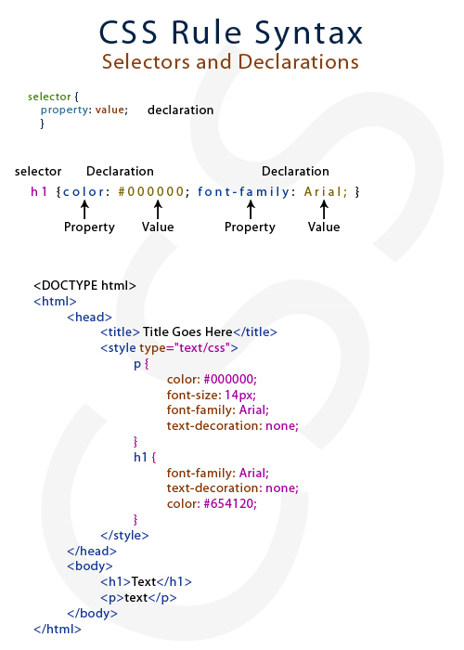

SOURCES

<http://www.vordweb.co.uk/css/advantages-of-css.htm>

<http://www.wmtips.com/css/advantages-using-css.htm>

<http://sadiakomal.com/the-advantages-of-using-css-for-web-page-design/>

<http://www.studiopress.com/design/css-sprites.htm>